**Page Builder**

* Page Builder is an Adobe extension for creating content by dragging-and dropping pre-built controls.

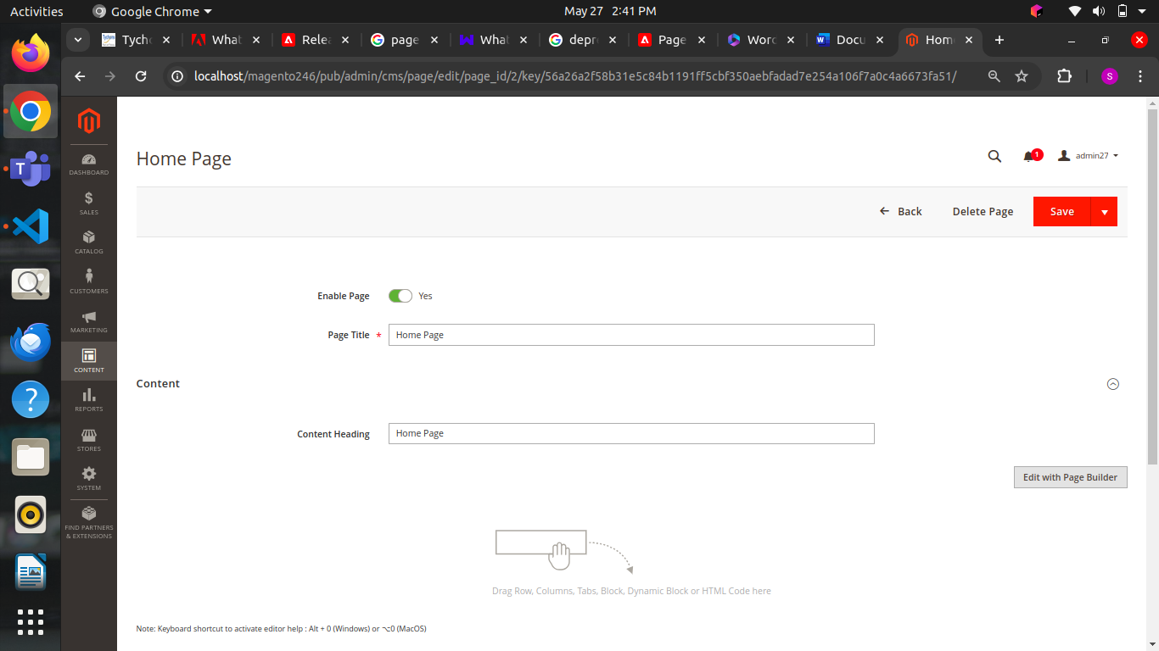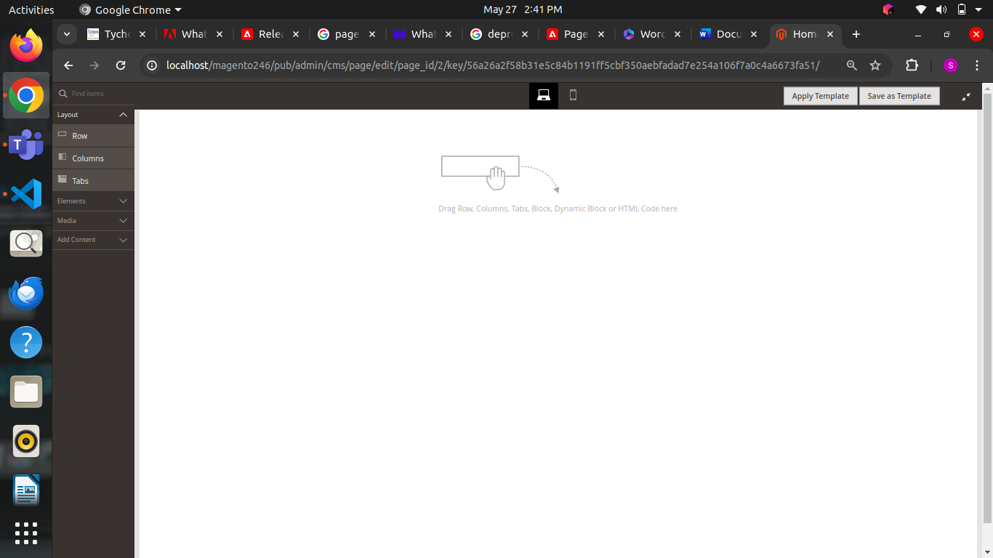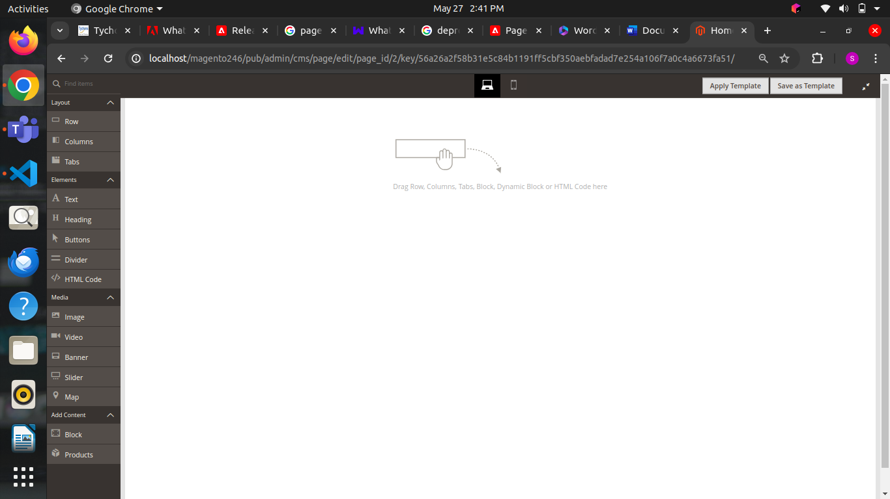

* Drag-and-drop functionality for content creation.
* Live previews of how the content will look on the storefront.
* Form editors for entering and customizing the content.
* For end-users, this means nocodingrequired. For you as a developer, it means you will use content types to customize Page Builder to meet the end-user's needs. There are two ways to customize Page Builder using content types:
* Extend existing content types
* Create new content types

**Sample page creation using page builder:**

**Create a new page**

1. On the Admin sidebar, go to Content >Elements > Pages.

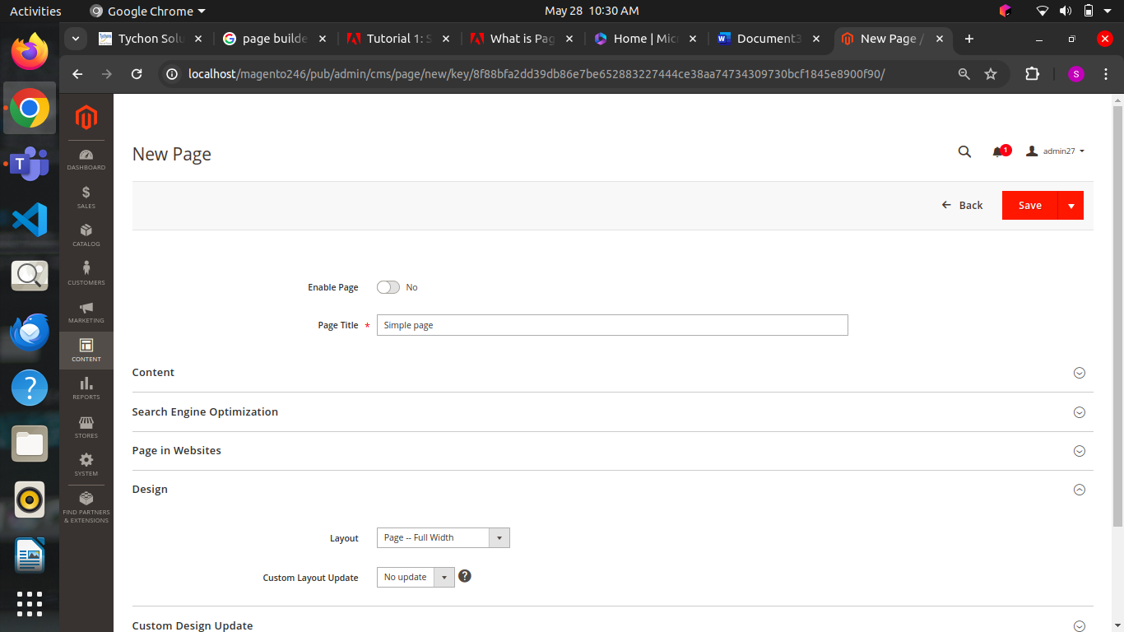

1. In the upper-right corner, click **Add New Page** and do the following:

* To prevent this page from being published in your store, set Enable Page to No.
* For Page Title, enter Simple Page.

1. Expand the Design section.

Notice that Layout is set to Page -- Full Width by default. In addition to the five standard [layout](https://docs.magento.com/user-guide/v2.3/design/page-layout.html) options, Page Builder adds full-width layouts for pages, categories, and products.

1. If the sample data is available, set New Theme to Magento Luma. Otherwise, you can choose another available theme or leave it blank to use the default theme.

The New Theme setting can be used to override the default theme and to apply a different theme to the page.



**Format the row:**

Expand the Content section and take note of the following workspace features:

* Page Builder [panel](https://docs.magento.com/user-guide/v2.3/cms/page-builder-workspace.html) on the left
* [Stage](https://docs.magento.com/user-guide/v2.3/cms/page-builder-workspace.html) with empty row where you can drag content types or columns
* over the empty row to display the toolbox.
* Each content container has a toolbox with a similar set of options.
* In the Row toolbox, choose the setting icon.
* Under Appearance, choose Full Bleed.
* The Full Bleed appearance setting extends the left and right borders of the content area of the row and background to the full width of the page.

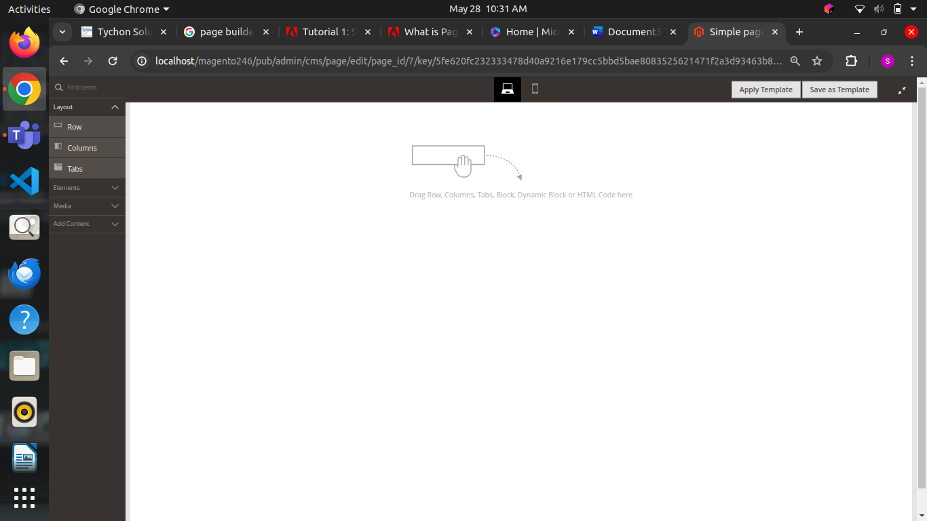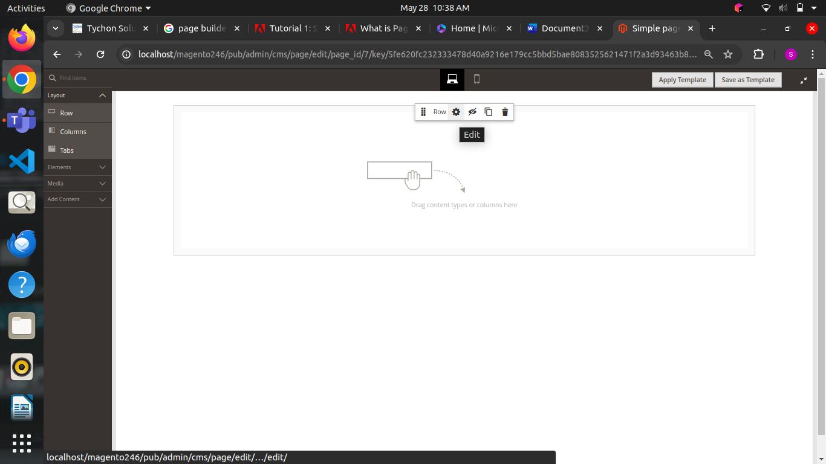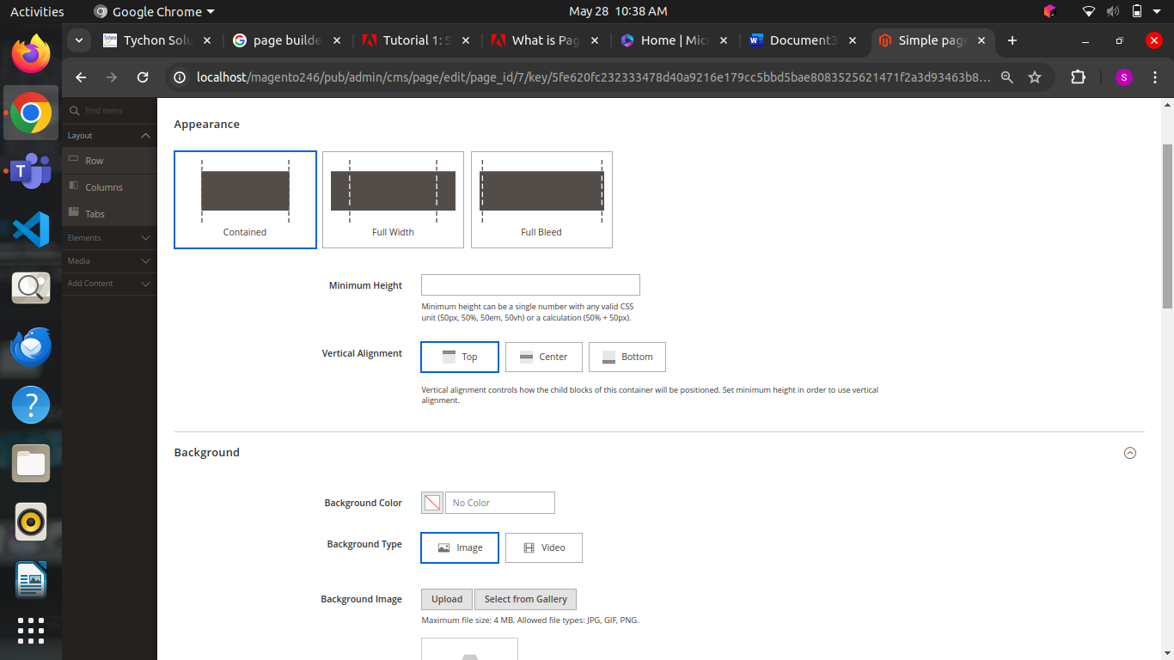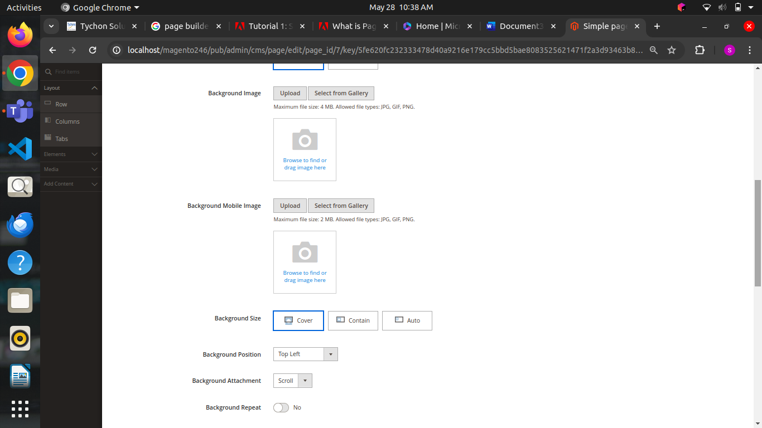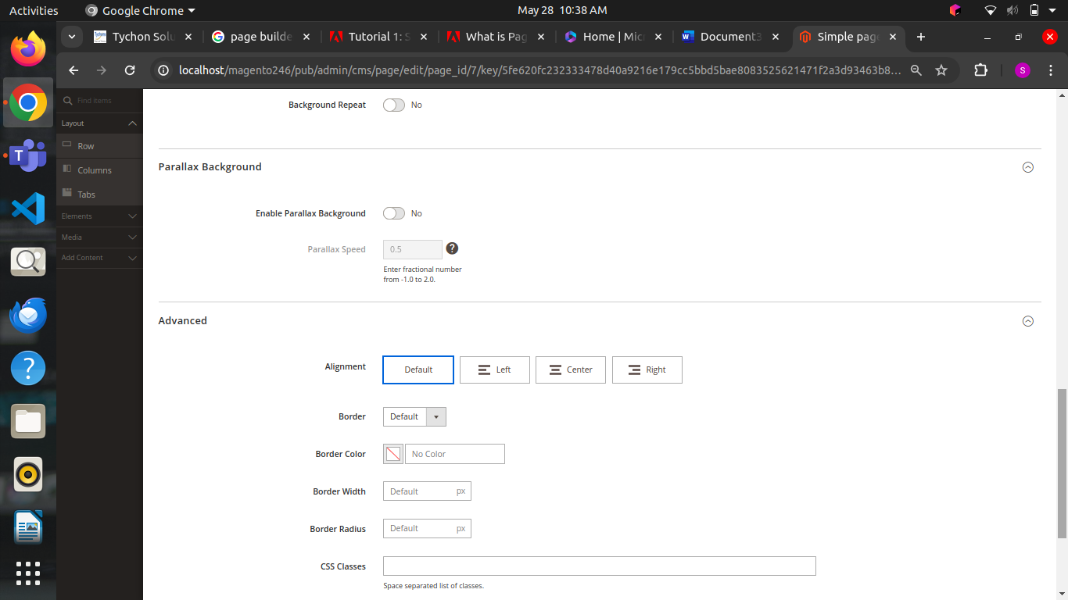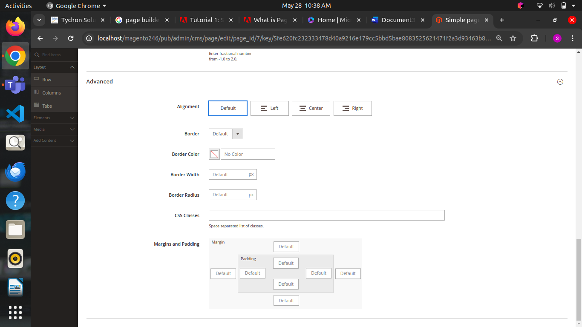

* Scroll down to the Advanced section and set all Margins and Padding settings to 0.
* This setting ensures that the banner extends the full width of the row.
* Scroll up to the top of the page and click **Save** in the upper-right corner to save the settings and return to the Page Builder workspace.
* In the upper-right corner, click **Save** to continue.

**Add a banner:**

* Expand the Content section.
* In the Page Builder panel, expand Media and drag a Banner placeholder to the stage.
* The stage now has two content containers, each with a separate toolbox. Because the banner is nested inside the row, make sure that you are working in the correct toolbox.

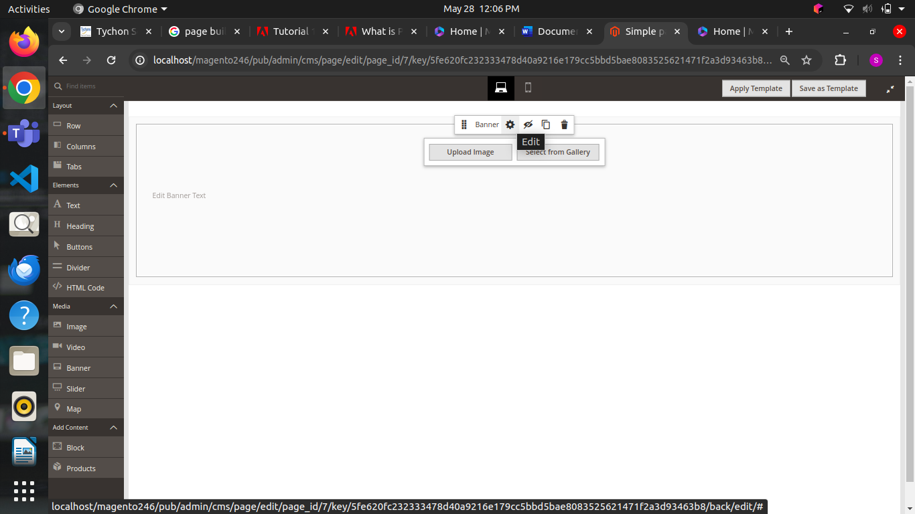

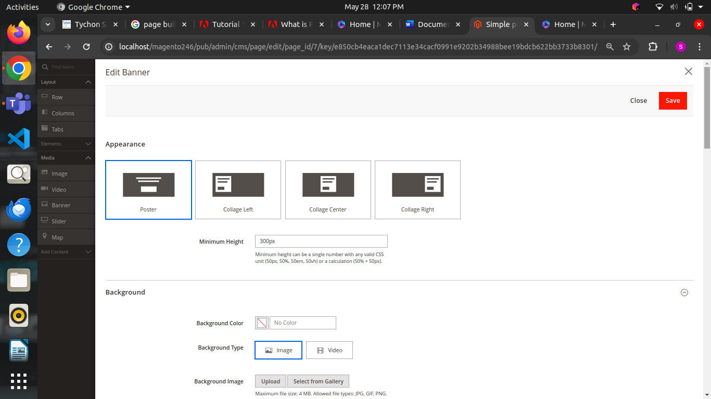

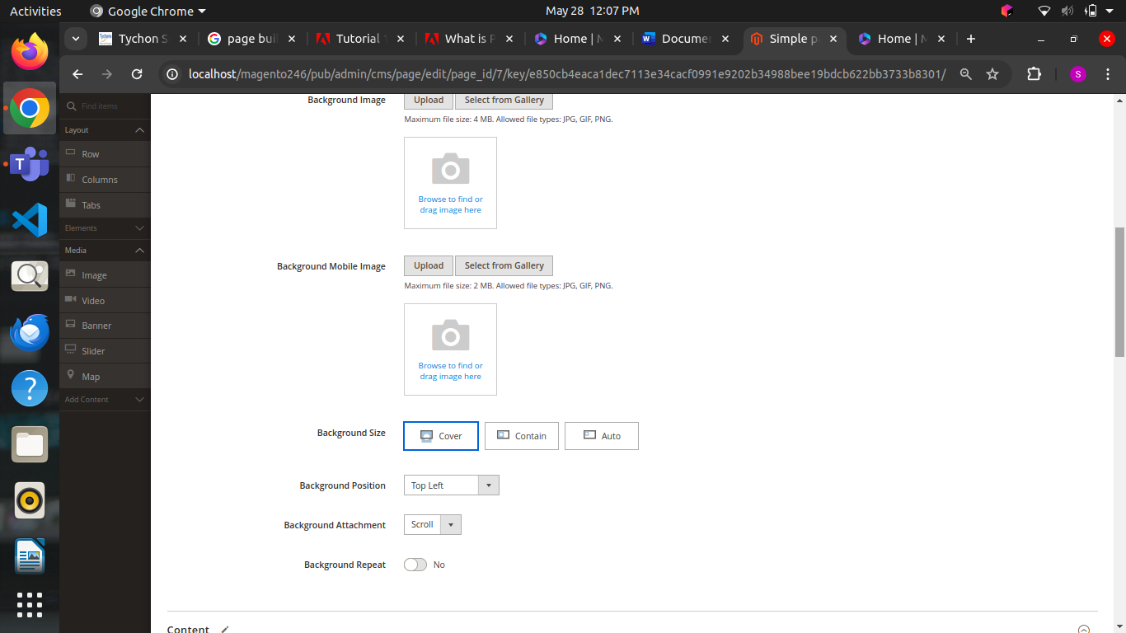

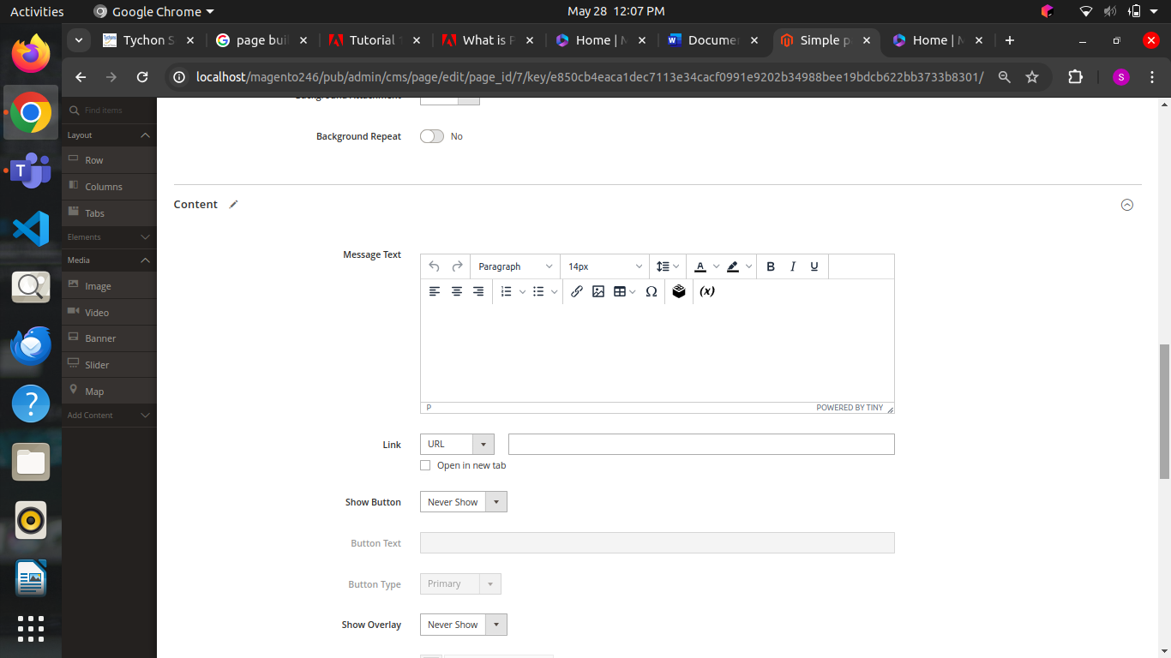

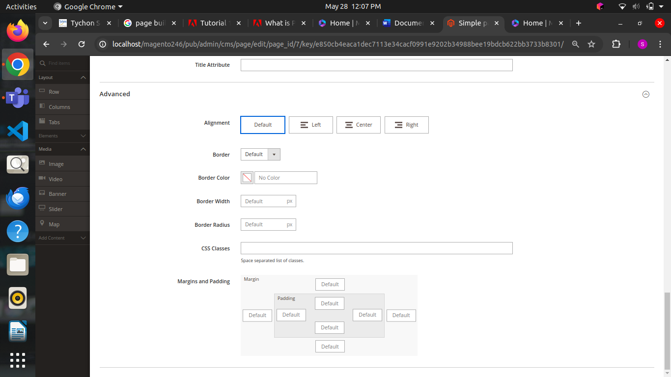

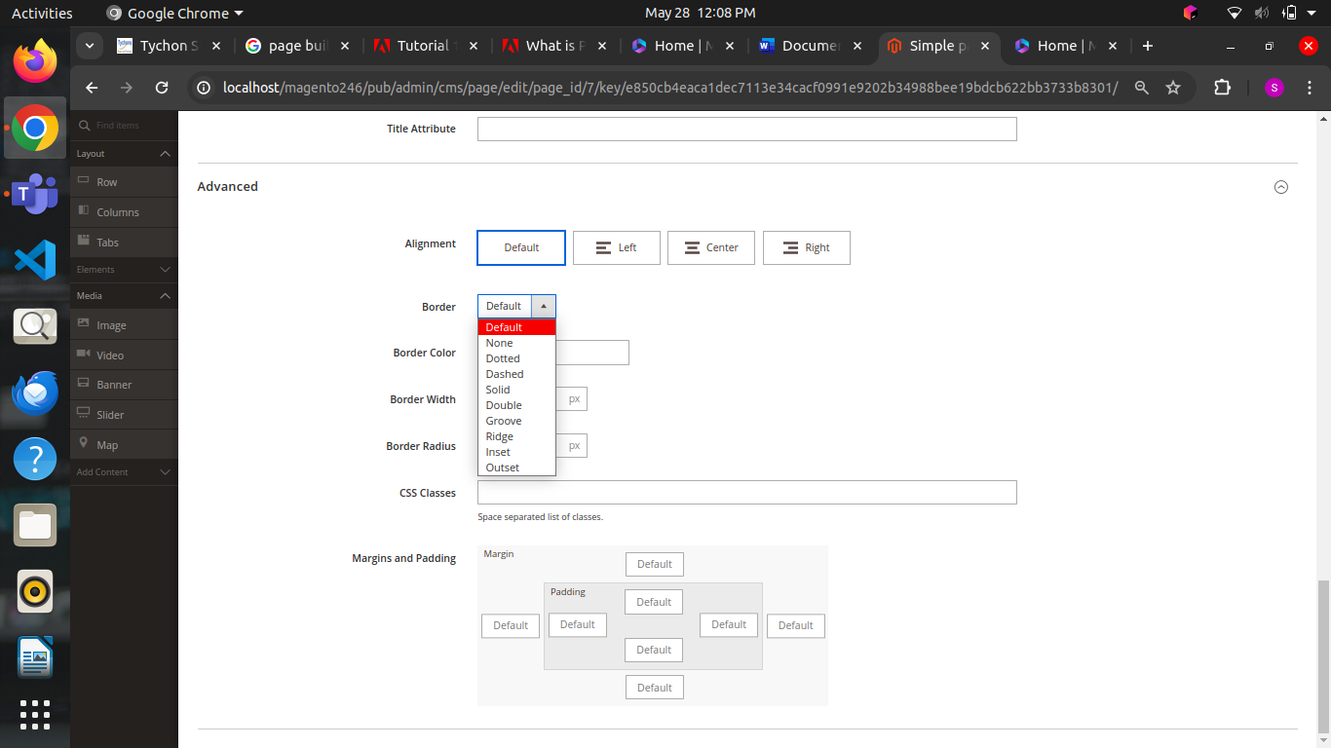

* In the Banner toolbox, choose the settings icon.
* Under Appearance, choose Collage Right.

The Collage Right setting positions content on the right side of the banner.

**Blocks in Pagebuilder**

* You can create a simple block with content from Google Maps. Simple blocks are sometimes called CMSblocks or staticblocksbecause the content does not change.
* A simple block is ideal for content that you might want to reuse.

### **Create a new block**

* On the Admin sidebar, go to Content >Element > Blocks.
* In the upper-right corner, click Add New Block.
* For Block Title, enter Google Map.
* For the Identifier, enter google-map.
* Choose the Store View where the block is to be available.

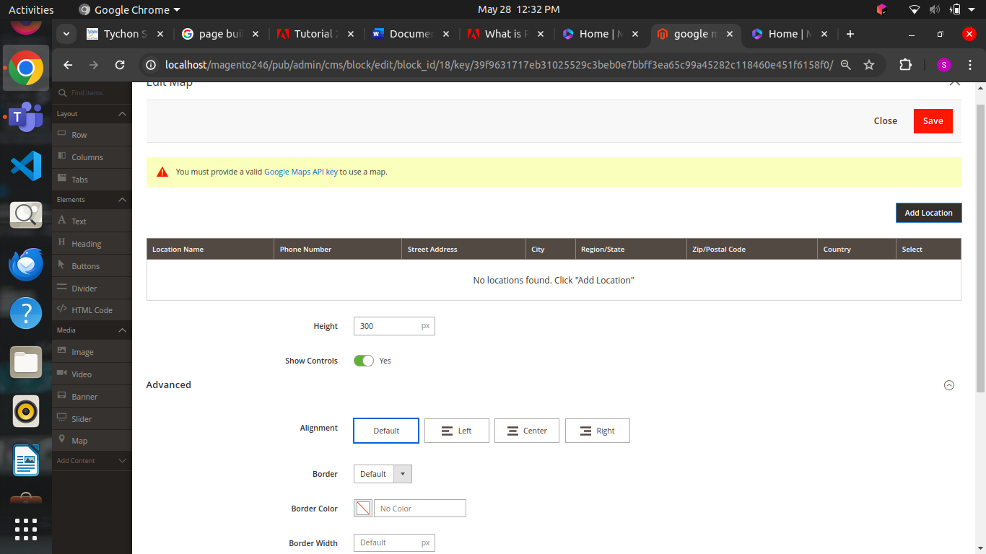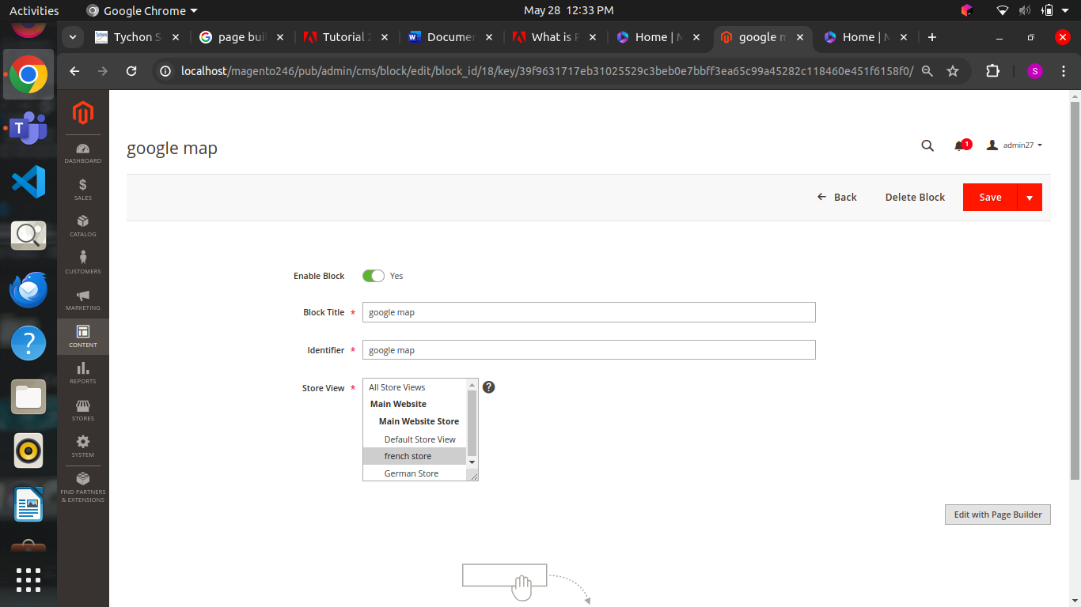

**Configure google maps:**

* Scroll down to the Page Builder workspace.
* In the Page Builder panel, expand Media and drag a Map placeholder to the stage.

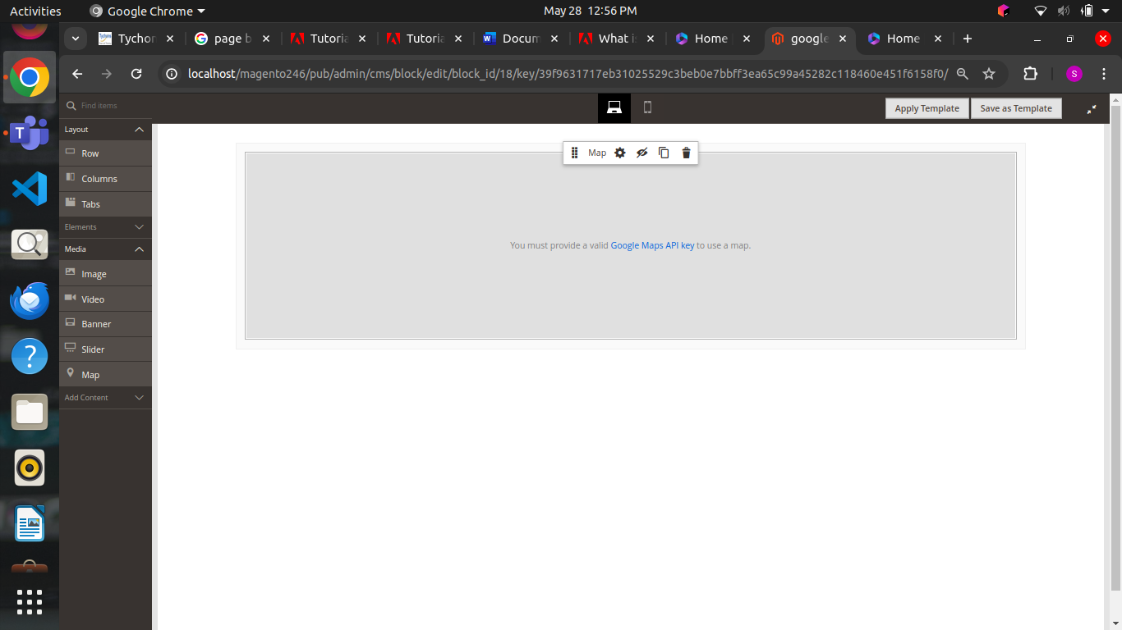

* A map to your store location appears if Google Maps is configured for your store.
* A placeholder map appears if Google Maps is not yet configured for your store.
* In the upper-right corner, click the Save arrow and choose Save & Close.
* Go to the [Google Cloud Platform Console](https://cloud.google.com/console/google/maps-apis/overview).
* Click the project drop-down and select or create the project for which you want to add an API key.
* Copy your API Key to the clipboard.
* Return to the Magento Admin and go to Stores > Settings > Configuration.
* In the left panel under *General*, choose Content Management.
* Expand the Advanced Content Tools.
* For Google Maps API Key, paste the key you copied.
* Click Test Key.
* If there is a problem with your key, return to the Google Maps Platform site to resolve the problem. Then, try again.
* After your key is verified, click Save Config.

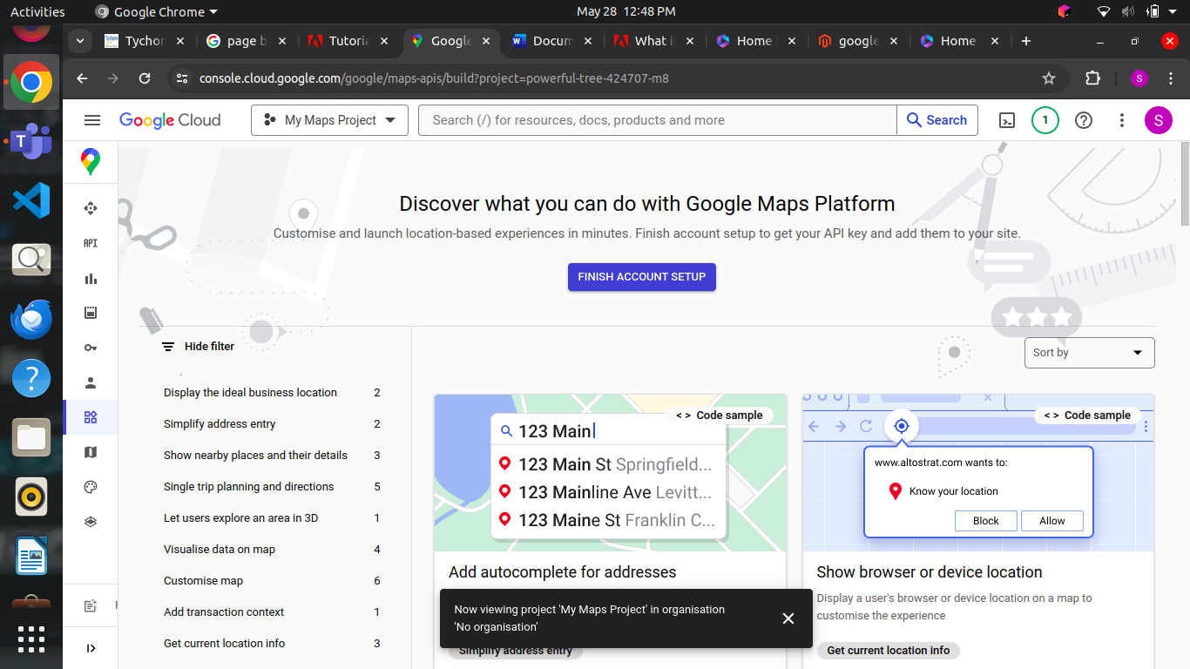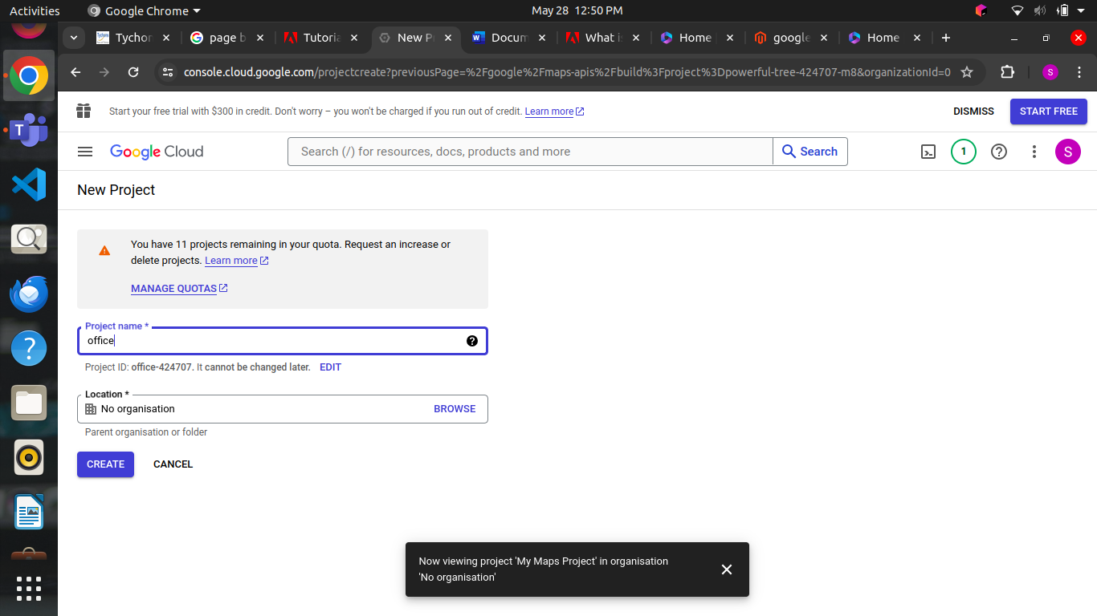

* + In Page builder the layout has rows, columns and table.
  + This option will provide a basic layout setup
  + In Elements tab we having Text, Heading, Button, Divider, Html code
  + In text option we can be able to add text in the created page
  + In Heading option, we can be able to add heading in the created page
  + In Button we can able add new button in page
  + These options are very useful to non-developers to create a page and block for the website without using programming we can be able to add the buttons and text.